Recreating Paging Slips
How to recreate paging slips in the event that the printer messes up and the request is gone.
- In Sierra, go to create lists using the function drop down
- Find an empty file, highlight it, and click search records
- Name the file and change the “store record type” to item
- Set the search parameters
  - For Local holds
    - Item (i) | Location (79) | Starts with (^) | ff
    - AND Item (i) | Hold (8) | exist (e)
    - AND Item (i) | Status (88) | equal (=) | Available (-)
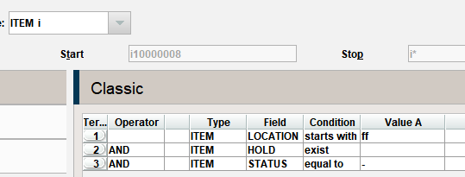
  - For OhioLINK holds
    - Item (i) | Location (79) | Starts with (^) | ff
    - AND ( Item (i) | Status (88) | equal (=) | Requested (&)
    - OR Item (i) | Status (88) | equal (=) | Ohiolink Paged (() | )

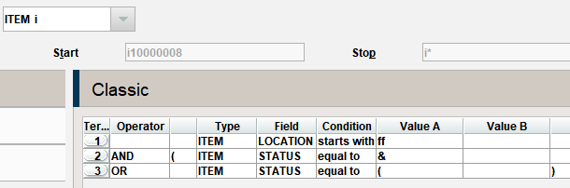
To add the parentheses across the terms, highlight both lines and click group
- Click search. This will bring up a list of everything that should be pulled
  - For local Items
    - Open the list to see all the items
    - Double click the first title to open the record
    - Click on the item level hold tab and click print at the top to create a pull slip
    - Write down the call number on the slip and the patron’s name across the top edge
  - For OhioLINK items
    - Write down what you need to create your pull list, you’ll print the slips later
- When everything is pulled you’ll need to process the hold and create a slip for OhioLINK items
  - For Locals
    - Use the normal process to fulfil the hold
    - Make sure to pay attention to the pickup location
  - For OhioLINK
    - Go to “InnReach: Check out to remote site” to create the paging slip
    - Scan the barcode
    - Click ok on the dialog box that comes up
    - Sierra should now display the InnReach information, at the top of that screen click Print
    - Retrieve the slip from the printer, highlight the stop number, fold it in half, and place in the book
    - Repeat for each item

